Project Design Phase-II
Customer Journey Map
Date | 02.02.26
Team ID | LTVIP2026TMIDS85199
Project Name | AutoSage App Using Gemini Flash
Maximum Marks | 4 Marks

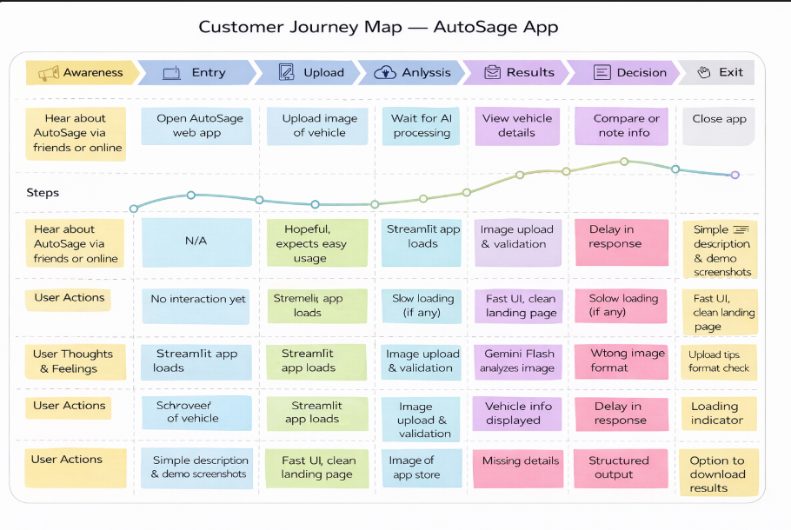
Customer Journey Map-AutoSage App

